**2018 SANTA CRUZ II ITINERARIES**

**DAY-BY-DAY DESCRIPTIONS**

|  |
| --- |
| TOUR DETAILS |

Tour Name

SANTA CRUZ II Northern Galapagos. 5 Days/4 Nights (Monday to Friday)

Description

From beautiful beaches to iconic visitor sites that make the Galapagos what it is, this itinerary encompasses a numbers of visitor sites that are filled with geological history and beautiful wildlife. All throughout the islands of Santiago, Rabida, Bartolome and the far-off isle of Genovesa – otherwise known as “Bird Island” – this is a journey that is sure to enchant with its unforgettable experiences.

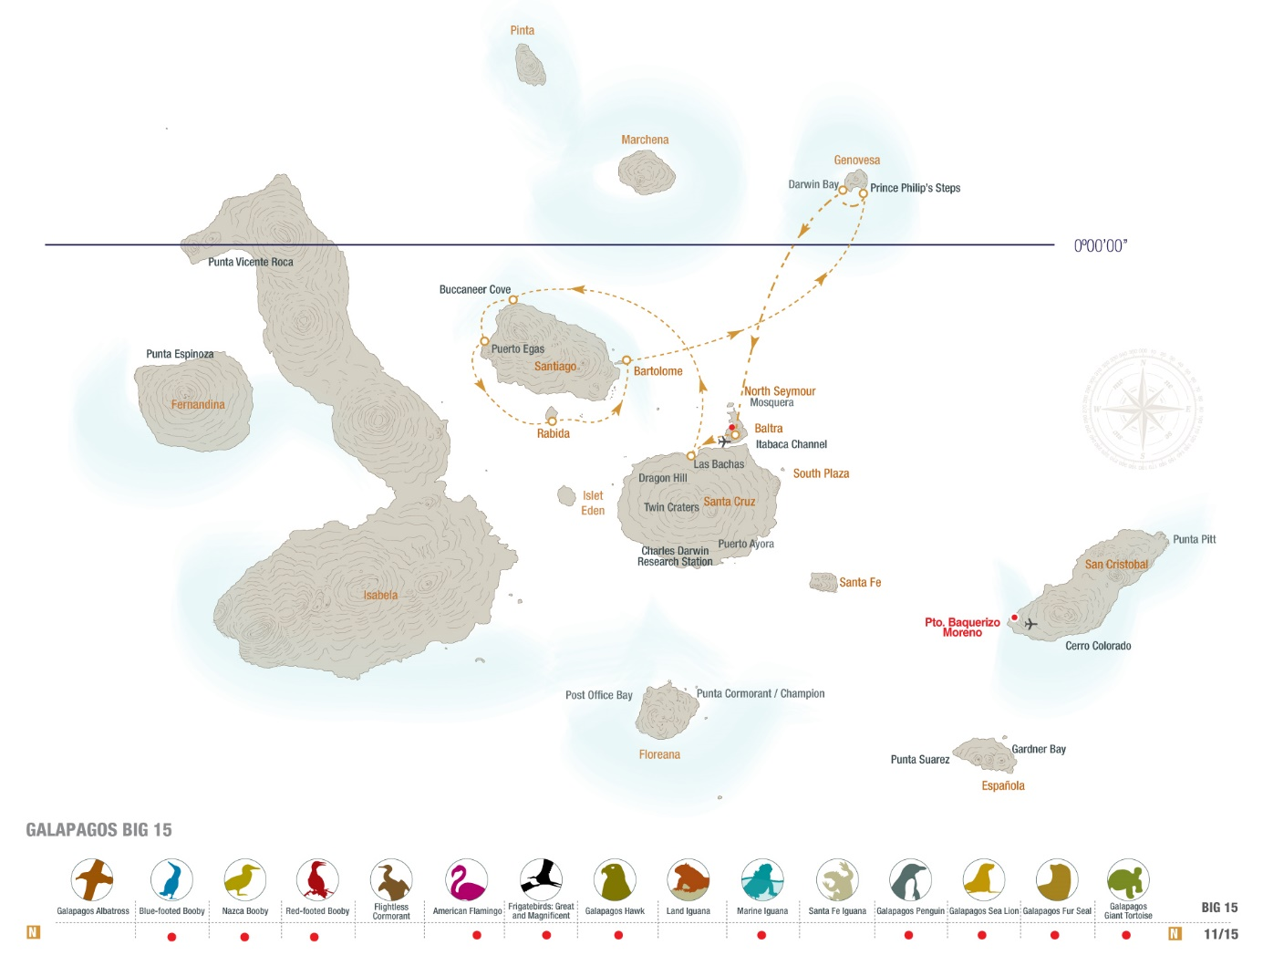

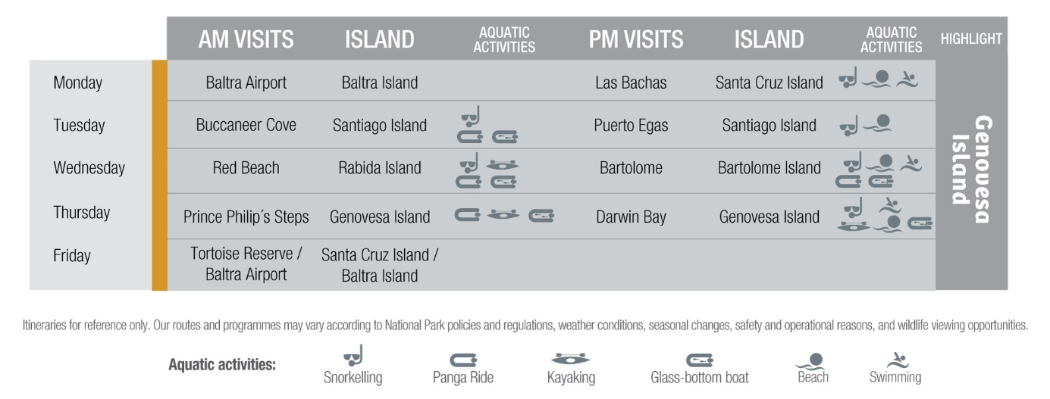

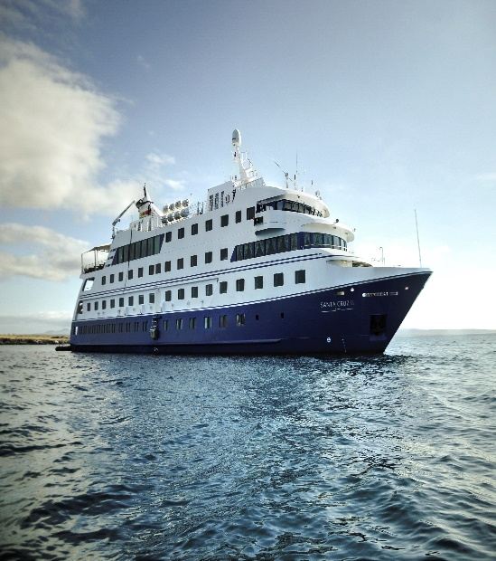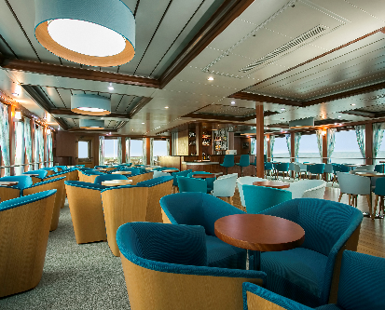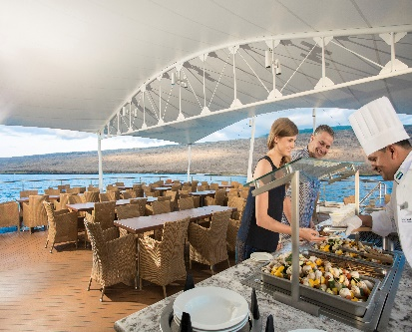

**Day 1- Monday**

**BALTRA/SANTA CRUZ**

**Baltra Island**

We land at Baltra Island by plane in the morning and transfer to the dock to board the Santa Cruz II, where we receive a welcome introductory briefing, boat drill and lunch.

**Las Bachas (Santa Cruz Island)**

This beautiful visitor site is located on the north shore of Santa Cruz Island, a glorious white beach with a couple of brackish lagoons only a few steps away from the sea. These lagoons are the feeding grounds of various wading birds, from stilts to flamingos. You may enjoy swimming at this beach. Welcome cocktail, expedition plan for Tuesday and dinner.

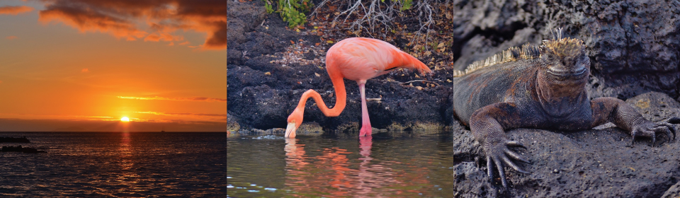

**Day 2- Tuesday**

**SANTIAGO**

**Buccaneer Cove (Santiago Island)**

After breakfast, we explore the coastline along the impressive cliffs of Buccaneer Cove, learning about the area’s distant and recent history. The cove is home to a large number of marine birds, sea lions, and inter-tidal organisms. Enjoy fantastic natural formations such as the “Elephant Rock”, “The Bishop” and an impressive natural cave. Opportunity for snorkelling, and a ride on the panga or glass-bottom boat are available.

**Puerto Egas (Santiago Island)**

Once we disembark at the beach, we can enjoy a swim or snorkel amid a rocky shoreline, usually in the company of marine turtles. From here, we head off to our walk, a great opportunity to see land and marine birds amid landscape of tuff-stone layers and lava flows. At low tide, marine iguanas graze upon the algae beds and we can also observe a colony of fur seals.

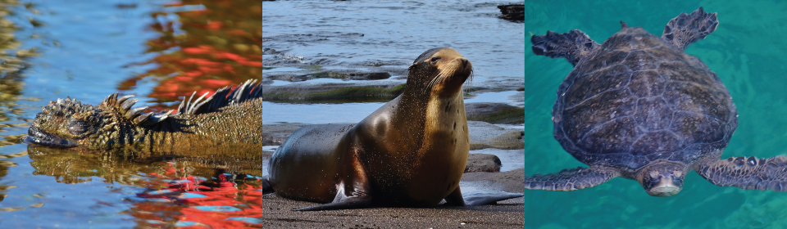

**Day 3- Wednesday**

**RABIDA/BARTOLOME**

**Rabida Island (Jervis)**

Some groups will go for a fascinating panga ride along the shores while others will disembark on Rabida Island’s red-coloured beach, caused by the unusually high content of iron in the volcanic material. Our walk brings us close to a colony of sea lions, marine iguanas, mockingbirds, yellow warblers and several species of Darwin’s finches. Very close to the beach, a brackish lagoon occasionally hosts American flamingos. This is a great place to snorkel from the beach, both for beginners as well as for experienced a glass-bottom boat ride, due to the unique combination of underwater species and submarine landscapes. During navigation to our next island, we can sometimes spot dolphins!

**Bartolome Island**

Today’s afternoon activities begin with a wet landing on the golden beach of this famous island, dominated by the imposing Pinnacle Rock. There’s great snorkelling and swimming from the beach plus the chance to ride the glass-bottom boat. After returning to the ship, we split into two groups: the first lands for a hike to the summit of this diminutive island that boasts fantastic views of the archipelago. This is a moderately steep climb aided by a wooden staircase, resting platforms and handrails – the view from the top is worth the effort! The second takes to the pangasto explore the rugged and volcanic shoreline. The groups then swap so that each one experiences the full beauty of this island.

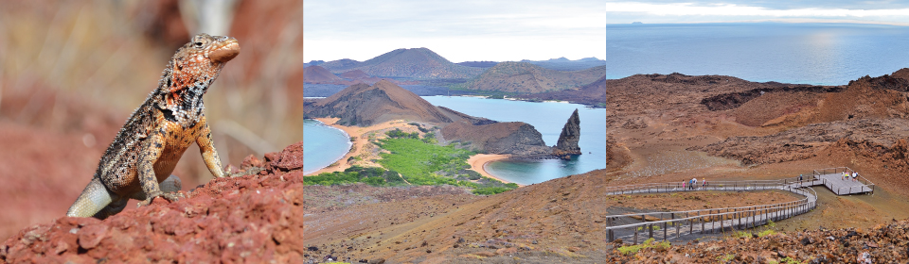

**Day 4- Thursday**

**GENOVESA**

**Prince Philip Steps** **(Genovesa Island)**

The morning starts with a steep climb (only 90 feet) up some stairs to reach a flat rocky plateau. Along our walk, we can observe large colonies of Nazca boobies, red-footed boobies, great frigate birds and storm petrels. Those not wishing to disembark can enjoy a longer panga ride along the cliffs (depending on weather conditions). Kayaking activities are available

**Darwin Bay (Genovesa Island)**

In the afternoon, we land at this beautiful beach to enjoy some swimming and/or snorkelling. Following our dip, we take an easy stroll to observe hundreds of birds, mainly frigate birds, red-footed and Nazca boobies, gulls, herons, finches and mockingbirds. Snorkelling, kayaking and swimming activities are available.

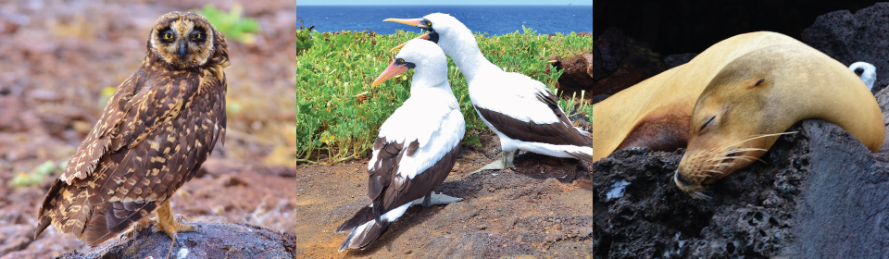

**Day 5- Friday**

**BALTRA**

**Tortoise Reserve – Baltra airport**

We start our last morning at the north shore of Santa Cruz Island. After breakfast, your luggage will be taken to the airport, while you visit the Tortoise Reserve. A dry landing at a passenger’s wharf and a bus ride to the loftier region of the island will provide the last highlight of the cruise: giant tortoises in the wild. The windward slopes of the island are home to two species of giant tortoises. These lush highlands include dense forests of Galapagos daisies, orchids and bromeliads, and several endemic land birds. After this visit we will transfer directly to Baltra airport. Farewell to Galapagos.

**Notes**

Please remember that the exact route and programme may vary according to weather and ocean conditions and the wildlife we encounter. It's also subject to change without previous notice due mainly to readjustment of the National Park policies and regulations.

**-Dry landing**: guests step from the panga (dinghy) onto rocks or a dock.

**-Wet landing:** as the dinghy edges onto a sandy beach, guests step into around 8 inches (20 cm) of water and wade ashore.

**PACKING CHECK LIST**

* 1 small backpack
* Comfortable walking shoes
* Sneakers with rubber soles
* Shorts
* Long pants
* T-shirts
* Long and short sleeved shirts
* Wind breaker
* Bathing suit or a wetsuit for snorkelling in cold months
* Hat or cap
* Sunblock and repellent
* Sunglasses
* Binoculars
* Camera & video recorder
* Any medicine you may be taking
* Book/Notebook

Included

All meals, island sightseeing, naturalists and lecture services, snorkelling gear and transfers.

Not Included

Air tickets to/from Galapagos, Galapagos National Park admission fee (US $100 subject to change without notice), transit Control Card for Galapagos (US$ 20 per person), wet suits, alcoholic and non-alcoholic beverage, tips, gifts, internet* and additional items.

* Due to the Galapagos’ remote location, internet connections are intermittent and low-bandwidth.